3.83: a) The position of the bolt is and the position of the floor is (2.50 m/s)t. Equating the two, 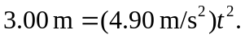 Therefore 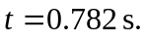 b) The velocity of the bolt is relative to Earth, therefore, relative to an observer in the elevator c) As calculated in part (b), the speed relative to Earth is 5.17 m/s. d) Relative to Earth, the distance the bolt travelled is

